**1.IMPLEMENT PROGRAMS FOR TIME SERIES DATA CLEANING, LOADING AND HANDLING TIMES SERIES DATA AND**

**PRE-PROCESSING TECHNIQUES**

**AIM:**

**To implement programs for time series data cleaning, loading and handling times series data and pre-processing techniques**

**PROGRAM:**

**import pandas as pd**

**import numpy as np**

**import matplotlib.pyplot as plt**

**from sklearn.preprocessing import MinMaxScaler**

**from scipy import stats**

**# Step 1: Generate Synthetic Time Series Data**

**np.random.seed(42)**

**date_range = pd.date_range(start='2024-01-01', periods=60, freq='D')**

**prices = np.random.normal(loc=100, scale=5, size=60)**

**# Introduce missing values**

**missing_indices = np.random.choice(60, 6, replace=False)**

**prices[missing_indices] = np.nan**

**# Introduce outliers**

**outlier_indices = np.random.choice(60, 3, replace=False)**

**prices[outlier_indices] = [200, 250, 180]**

**# Create DataFrame**

**df = pd.DataFrame({'Date': date_range, 'Price': prices})**

**# Save to CSV**

**csv_path = 'petrol_prices_timeseries.csv'**

**df.to_csv(csv_path, index=False)**

**# Step 2: Load Data**

**loaded_df = pd.read_csv(csv_path, parse_dates=['Date'])**

**# Step 3: Handle Missing Data**

**loaded_df['Price'].fillna(method='ffill', inplace=True) # Forward fill**

**# Step 4: Detect & Remove Outliers**

**z_scores = np.abs(stats.zscore(loaded_df['Price']))**

**loaded_df = loaded_df[z_scores < 2] # Keep values within 2 standard deviations**

**# Step 5: Normalize Data**

**scaler = MinMaxScaler()**

**loaded_df['Normalized_Price'] = scaler.fit_transform(loaded_df[['Price']])**

**# Step 6: Visualize Data**

**plt.figure(figsize=(12, 6))**

**plt.plot(loaded_df['Date'], loaded_df['Normalized_Price'], marker='o', linestyle='-', color='b')**

**plt.xlabel('Date')**

**plt.ylabel('Normalized Petrol Price')**

**plt.title('Time Series Visualization of Cleaned Petrol Prices')**

**plt.grid(True)**

**plt.show()**

**OUTPUT:**

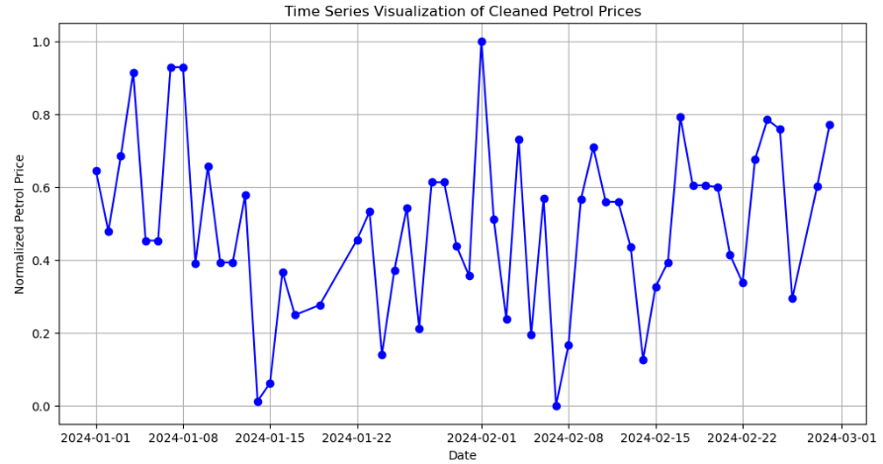

**RESULT:**

**The program to implement time series data cleaning, loading and handling times series data and pre-processing techniques has been executed successfully**